**Cyber Security Technician Final Portfolio**



***Executive Summary:***

***“In 2020 breached organisations spent on average £2.9 recovering from security incidents caused by cyber-attacks”***

*Thank you for inviting me to assess your business’ IT systems at a time when companies are at their most vulnerable to cyber-attacks, which has in some cases resulted in crippling financial loss and irreparable reputational damage; especially in situations where the breach could have been prevented by adopting basic and cost-effective security measures.*

*Whilst it is fantastic that your business is thriving, after assessing your business, it is obvious that you run a huge risk of financial ruin due to the many security failings within your business at present. I sincerely hope that the damage has not already been done to you, your suppliers or customers. It is absolutely imperative that you take immediate action in improving all physical, technical & procedural aspects of your security.*

*If you follow this report, then you can look forward to continual growth, safe in the knowledge that you are doing your best to keep your customers, suppliers, employees and profits safe from ever the increasingly sophisticated cyber-attacks!*

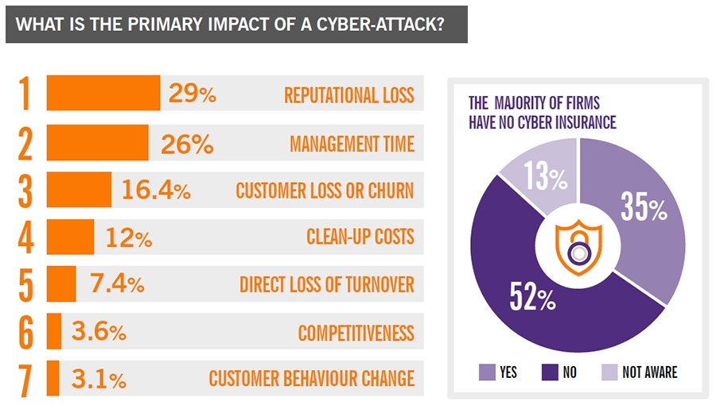

**Introduction:**

Congratulations on your recent growth and expansion from 45 to 55 employees! Now your business exceeds 49 employees your status changes from a small to a medium sized business so you now qualify as a Relevant Digital Services Provider (RDSP) which means that alongside GDPR, you are now regulated by the ICO (Information Commissioners Office). You’ll have to adhere to NIS (Network and Information Systems Regulations 2018) which covers a much broader range of incidents than GDPR. A violation of NIS can result in significant financial penalties up to 17m.

NIS vs GDPR: NIS concerns the security of network and information systems and the digital data within them whilst the UK GDPR concerns the processing of personal data. Digital data refers to any data relating held within the network and information systems.

After inspecting of your business here are my findings:

**Most likely cyber threats that the business needs to protect itself against**

Please see attached Appendix I for a detailed explanation of each of the following cyber threats:

1. **Supply Chain Attack**
2. **Spear / Whale / Phishing Emails**
3. **Ransomware**
4. **URL interpretation/Broken Access Control**
5. **Man-in-the-Middle Attack**
6. **Zero-Day Exploit**
7. **Denial-of-Service**
8. **Injection**
9. **Trojan Horse**
10. **Drive by attacks**
11. **DNS Spoofing**
12. **Business email compromise**
13. **Identification/Authentication Failures**
14. **Cryptographic Failures**
15. **Insecure Design**
16. **Security Misconfiguration**
17. **Vulnerable/Outdated Components**
18. **Security Logging and Monitoring Failures**
19. **Brute Force Attack**
20. **Dictionary Attack**
21. **Rainbow Table**

**Your current vulnerabilities**



**Physical**

* Easy access to gain entry though the loading bay to the main office and MD’s office.
* A server that isn’t backed up puts you at risk of losing all data that you would not want to lose if damaged, lost, stolen or compromised.
* Server, printer and router in the MD’s office vulnerable to unauthorized access to print data obtained by hacking into the server or router.

**Procedural**

* No employee cyber awareness training.
* Staff are using the simplest passwords for hackers to exploit e.g. ‘guest’.
* Unattended PC’s left unlocked in the general office, giving anyone access to hack or steal data.
* I could visit any dubious websites on any of your computers.

**Technical**

* A consumer wireless router and switch are not suitable for business use, especially as your business scales. Both could be very costly in the long run.
* Daisy chain network: if a hacker gains access to one of your computer systems, they can then ‘piggyback’ onto other systems causing further damage. Daisy chain networks are also very slow and if there’s a problem with once device, it can cause the whole network to go down.
* Your offsite hosted website for taking orders, keeping customer details and linking to an online payment service, written and currently maintained by a local software developer who you don’t seem to know much about. Could he have a conflict of interests?
* No USB security to control the access of devices to your USB ports.
* Your employees are connecting their laptops and mobile devices to public wi-fi connections when they are travelling which leaves them wide open to attacks.
* With the exception of finance and personnel folders I could copy and read any Customer, Sales/Marketing, Production, Research/development and Supply Chain Management files on your server.
* I was able to install software without any access issues.
* You have Remote Desktop open to the internet: Hackers are continually scanning the internet looking for such open ports leaving you wide open to denial of service or theft of valuable information!

**How these vulnerabilities should be fixed**



**Physical**

* Barbed wire tall fences and locked gates on external perimeters.
* To gain entrance to the building, warehouse staff should have separate access to office staff with strict security monitoring measures for employees to move between departments e.g. key cards & security monitoring 24/7/365.
* To gain entry to the main office, you should first have to bypass a reception or security check which only allows authorised personal to pass through with CCTV and logging of each entry.
* Backup your data: creating copies of data held within your systems & saving it to another device or to cloud storage.
* Regular backups (preferably automatic) so that your backups are always up to date with your business operations.
* Servers, routers, switches, firewalls should be locked away and protected in layered security, making it impossible for intruders to gain physical access.
* Servers should be held within the deepest layer and protected not only from unauthorised access, but also from the elements e.g. humidity, temperature, fire, water as well as motion/door sensors & CCTV.

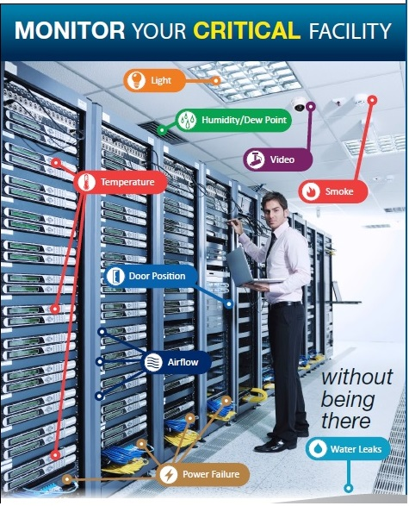

**Procedural**

* Hire a DPO (Data Protection Officer) or recruit internally, but it has to be a responsible employee whose current role wouldn’t be conflicted e.g. Senior Management, IT or Marketing Managers, or you could outsource externally which could help your organisation address the compliance demands of the GDPR while staying focused on core business activities.
* Design & document your effective backup and recovery system and schedule.
* Decide how you will delete redundant data.
* Implement the 3-2-1 rule (see Appendix II).
* All employees/management to undergo in depth annual cyber & GDPR awareness training where each employee can only resume their normal duties upon successful completion of the exam.
* Have a pre-prepared plan in place for recovery in the event of severe malware attacks (backup and recovery).
* Take out a good cyber liability insurance policy.

**Access control policies:**

* Decide on access privileges and how to prevent employees from visiting harmful websites.
* Control who is permitted access to business systems based on their position and responsibilities within the company.
* Strict policy must be in place to remove all access in the event of an employee ceasing to work for the business.
* Monitor and control of important employee actions to safeguard against tampering.
* Decide on formal policies prohibiting the use of unauthorized software (whitelisting vs blacklisting)
* Decide on group policy uses such as access to Control Panel, Settings, Command Prompt and lock out policies for incorrect password entries.

**Technical**

* USB control & encryption: protect your valuable data by encrypting it (or the portable device it is stored on) before it leaves the business network.
* Upgrade from consumer grade to business routers. Business routers favour security, scalability, traffic management, Robust VPN support & remote access.
* Business/Managed switches – manage, configure and monitor your network better, giving you greater control over how data travels and who can access that data.
* Use a business VPN e.g. Cisco for working outside the office and connecting to public networks so that your data will be encrypted and protected.
* A total revamp of your current website, online payment systems and all databases using a reputable software developer who is not local and specialises in the design and maintenance of websites for medium size businesses.
* Main Systems & Remote Desktop: Limit users who can log-in, use 2 Factor Authentication and ensure to disconnect or timeout after inactivity at the end of each session.
* Use strong passwords (mixed case, minimum 14 characters, including at least 1 special character) for all systems with each important program e.g. email, payroll, payment systems, requiring a different login and password per user.
* Set an automatic prompt for users to change their passwords periodically with a verification check that the password doesn’t match the user’s previously used passwords.
* Change default passwords.
* Avoid generic user ID's e.g. ’admin’
* Apply correct rights and privileges for user and files. Use an ACL (Access Control List) to assign permissions to files and folders within the ACL.
* Configure security options on all OS and applications.
* Use CAPTCHAs for users to gain access to your website as a way to neutralise threats from automatic hacking systems.
* Control Windows updates centrally and prevent installation of unauthorised software.
* Ensure all passwords are hash encrypted which uses an algorithm to scramble any password length to a fixed size array e.g. 60 bytes to make it virtually impossible to crack.
* Use Salting to add extra security to hash encrypted passwords to defeat dictionary and rainbow attacks.

**Affordable network security measures you can easily implement:**

* TLS (Transport Layer Security): Easy and cheap to implement and continuously refined and updated. The most widespread standard for securing the upper layers of your network stack. Built into all major Web browsers to check the validity of client and servers' digital certificates before connecting to the server.
* Full and/or File disk encryption: to protect your information by converting it into unreadable code that can only be deciphered by authorised people/keys.
* Antivirus Updates: You need a good business grade antivirus software e.g. McAfee Total Protect which you need to keep constantly updated to handle the most old and new threats. Best to configure it to automatically check for updates daily.
* Patch management: Fix vulnerabilities on software that are susceptible to cyber-attacks to help the business manage its security risk ensuring software and applications are kept up-to-date and running smoothly.
* Business grade Firewall to act as a first defence against cyber threats and allow safe traffic to pass to your router or switch. e.g. Deep packet inspection Firewall to look deeper into network packets & block, reroute or log potential breaches. If the packet doesn’t pass inspection it is dropped/denied entry.
* Intrusion prevention systems (IPS) constantly watches your network, identifying possible incidents and logging information about them, stopping the incidents, and reporting them to security administrators.
* DMZ (Demilitarised zone): A subnetwork that sits between the untrusted public internet and your private network to protect from untrusted traffic passing through to your firewall

**Anti-malware:**

* Auto-scan email attachments and downloads for malware.
* Ensure all staff are educated and aware of hoaxes e.g. spam emails and how to handle them i.e. Report, don’t open and delete.

**Monitoring Controls (SIEM Security Information and Event Management):**

* Adopt Cyber risk management to detect and prevent early cyber threats and data breaches before they cause damage and disruption.
* Record all system activities such as user ID’s dates, times and details of key events e.g. log on, log off.
* Record Uses of privileges, applications, files, websites, transactions executed per user.
* Intrusion prevention systems (IPS) constantly watches your network, identifying possible incidents and logging information about them, stopping the incidents, and reporting them to security administrators.

**Required improvements to the network security:**

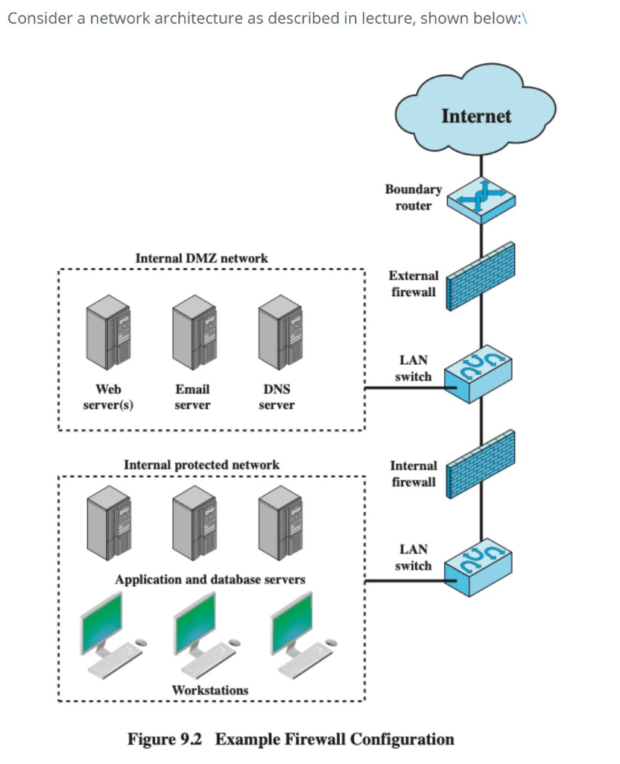

Use a hierarchical network which has the following benefits:

* Helps to design, install and maintain a high performance scalable, trustworthy, cost-effective hierarchical network.
* Better management and troubleshooting to isolate network issues.
* Better filters to cleanse traffic data

**The ongoing responsibilities of management:**



* Practise and promote effective cybersecurity.
* Define, classify and strategize the top business cyber risks.
* Benchmark your current status vs industry standards and your known vulnerabilities.
* Understand the risks and potential liabilities your business faces and to understand each individual's role during a cyber security incident.
* To ensure proper policies are put in place and regularly reviewed based on standard practises.
* To decide which systems require password protection and the level of password protect to needed to access each system.